**SM Bacoor Covid-19 Vaccination Simulation**

**Jan Eilbert Lee***Technological University of the Philippines*

**Abstract**

COVID-19 vaccination is broadly considered to offer the main course out of the COVID-19 pandemic, such that social restrictions can be facilitated and economic activity can securely continue without compromising healthcare services. For people going to a COVID-19 vaccination center, there are various key exercises that may be expected. Following that, the person would register and fill in some necessary information. After that, they will clinically assess to ensure suitability for the vaccine. They would then be vaccinated and observed or monitored to see if the vaccinated person experienced any side effects.

1. **Introduction**

The Philippines has among the highest COVID-19 infection rates in the region, entwined in the midst of economic and political ramifications. In nations like the Philippines, population adherence to vaccines might be critical to overcoming the pandemic. Nonetheless, it is subject to the population's eagerness to get the vaccine. Analysis of the historical backdrop of antibody take-up in the Philippines might feature entanglements and difficulties that might affect endeavors to disseminate a future COVID-19 vaccination.

COVID-19 vaccination is broadly considered to offer the main course out of the COVID-19 pandemic, such that social restrictions can be facilitated and economic activity can securely

**Daniel Christian Borromeo  
Rose Anne Eugenio  
Jaime Hanz Sibucao***Technological University of the Philippines*

continue without compromising healthcare services.

Vaccination of sufficiently large proportions of the population is necessary to reduce the various non-pharmaceutical interventions throughout the pandemic. Thus, this might consider all areas of the economy to be securely returned, quality of life to improve, and medical care administrations to continue their normal operations—including addressing the numerous neglected demands supported during the pandemic.

Alongside acute hospitals and family doctors a key setting for mass vaccination organization is the dedicated vaccination center. Frequently situated in malls, sports and leisure facilities, these are intended to give an effective high-throughput service for advance-booked people requiring vaccination.

Computer simulation was utilized to provide visualization and analytical tools. This showed possible queues with operational changes, processing times, and the number of staff required. Simulations allowed us to assess the overall performance of the SM Bacoor vaccination facility under various design scenarios and options.

For people going to a COVID-19 vaccination center, there are various key exercises that may be expected. Following that, the person would register and fill in some necessary information. After that, they will clinically assess to ensure suitability for the vaccine. They would then be vaccinated and observed or monitored to see if the vaccinated person experienced any side effects. After the whole process, the vaccinated person will leave the site. In this study, discrete event simulation is applied.

1. **Methods**

A discrete-event simulation model was developed to improve the queuing system and the waiting time of the patient at the vaccination site. For the simulation model's validation, the data from the vaccination site at SM Bacoor were employed and the modeling and simulation procedure was carried out using Simulation IO software. Below are the following approaches and processes used in the study.

1. **Patients Flow**

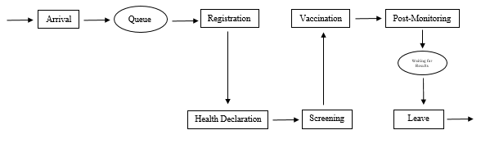The vaccination site we will use for the simulation process is located at the SM Bacoor. Patients will undergo some process to determine their eligibility for taking the vaccine shots. The process at the vaccination site will be shown in the figure below.

Fig. 1. Activity Cycle of the System

At the arrival station, all patients who needed COVID 19 vaccine injections will be accommodated, which means that there will be no limit to the number of patients who will be entertained.

Once they arrive at the venue, patients will be in the queue to fill up the forms given to them and control the crowd for the proper event organization.

After filling up the forms, they will proceed to the Health Declaration process where they will be interviewed by healthcare professionals regarding their healthcare status. This process is very significant because it will determine whether the patient is eligible, or not, to take the COVID 19 vaccines.

Then, they will move to the Registration process where they will give the registration form that consists of their basic information. This is to track the patient if ever complications will exist.

Patients will then proceed to screen after they have done registration. In the Screening process, healthcare professionals examine the results of the health declaration. If the patient is eligible to take the COVID 19 vaccine, then they will proceed to the Vaccination process. If not, then they will be assisted by the ushers to leave the site. Ineligible patients will be advised to seek their doctors for them to get the COVID 19 vaccines. While vaccinated patients will then proceed to the Post Monitoring station to monitor the after-effects of the vaccine they take. If the patient is allergic, they were given allergy medications to cure their allergies. If not, they will be assisted to the exit to leave the system.

This process is based on the narrative data given by the healthcare assistant on the said vaccination site. This will be the process used for the model in the simulation developed for the study.

1. **Simulation Method**

The Discrete-Event Simulation was the simulation method used in the study because its approach is simple and adaptable for modeling complex systems. The primary purpose of this simulation technique is to examine and evaluate numerous operational what-if scenarios and tactics to identify the most successful and efficient model. For instance, DES is very popular in healthcare settings that numerous healthcare events or situation is done by this method (Asgary et al., 2021). On the other hand, Simulation IO was the primary software used to design a model and develop the simulation that will be used in the study.

1. **Simulation Layout**

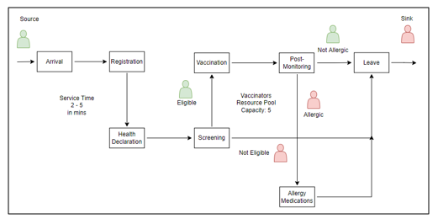At the beginning of the process, a simple simulation that served as the foundation for the simulation was established. Figure 2 shows the process flowchart we created that serves as the basis of the simple simulation that we established. This process flowchart shows the patient flow and is formulated based on the activity cycle of the system.

Figure 2. Process flowchart

One of the cinemas in SM Bacoor was chosen as the primary subject of this study to improve the waiting time of the patients and the queue in the system. To demonstrate the process, patients will serve as a temporary entity of the system, which means their role in the system is for a limited amount of time. They will arrive at the Arrival station with an estimated time of 0.7 min or 42 seconds. It is because there’s no queue at the beginning of the system unless they don’t know what the process will be.

Patients then will proceed to the Form station wherein they will get the forms that are needed to fill up. It has an infinite capacity of patients that can be accommodated and an estimated time of 3 secs to 1 minute. After filling up the forms, patients then proceed to the Health Declaration process. An estimated time of 2 – 5 minutes will be given on Arrival until the Health Declaration process.

The declaration of a patient’s health status should not be taken for granted so the amount of time spent on this process must be enough for the healthcare professionals to verify it. In this process, there is a limit of 20 patients in the queue and an estimated time of 5 to 10 minutes.

Next, the patient will now register for tracking purposes in case of complications will happen. Two permanent entities are assigned to this station with two working computers being used. Because of that, there are only 4 patients allowed in the process while the other patients will need to wait. Despite that, this process will only have an estimated 2 to 5 minutes. Short enough to minimize the waiting time of the other patients.

During the screening process, healthcare professionals will evaluate the health declaration of the patients. It should be properly assessed so the allocated time must be enough for the healthcare professionals. Patients will be limited to 10 so the others will be in the queue. There will be 5 to 10 minutes allocated in this process.

Once the patients are done with the screening they will now proceed to vaccination. Vaccines should be injected very quickly so there is only a small amount of time allotted in this process. There are 1 to 2 minutes allotted estimated time and only 6 patients will be vaccinated simultaneously while the others will wait until their turn.

The next process will be post-monitoring. Patients will stay for 15 to 30 minutes to monitor the after-effects of the vaccine. There will be a capacity of 200 patients that will be accommodated in this process. If the patient will experience an allergy, then they will proceed to the Allergy Medication. Else, they will allow leaving which is assisted by the volunteers. In the Allergy Medication station, 3 persons are at the initial capacity and the allotted time will be 6 to 18 seconds. However, these values are subject to change which means the allotted time and capacity of this station will still depend on the situation.

1. **Simulation Component**

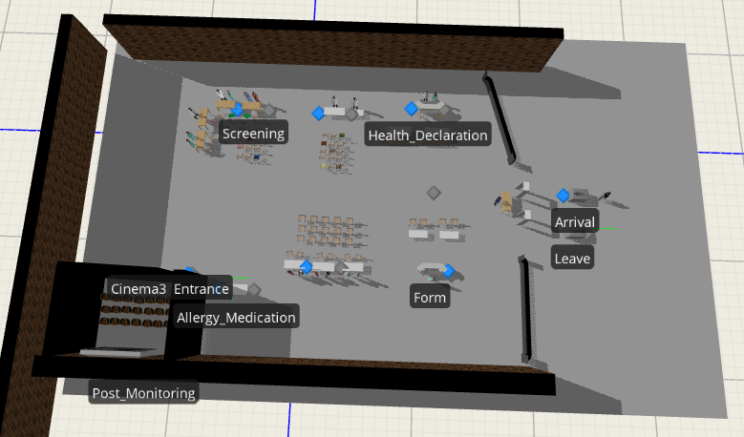We used Simulation IO as the primary software in developing the model. The simulation model is designed based on the actual vaccination site system in SM Bacoor. The elements for the modeling procedure came from the *Standard and Project Library* modules of the Simulation IO. The simulations could be shown in 2D and 3D formats, making it simple to comprehend the current situation at the vaccination site in SM Bacoor. Figure 3 shows the 3D model of the simulation model we developed.

Figure 3. 3D model visualization of the vaccination site in SM Bacoor

1. **Results and Discussion**

The main objective of developing the simulation models for the vaccination site in SM Bacoor was to enhance the queueing system and reduce the waiting time of the patients. Following a review of the simulation model’s compatibility with a typical vaccination site process operation, we will analyze whether the simulation imitation of the system is enough to minimize the operation time.

For each scenario, we set 10 replications and determine the number of patients that go through the system produced by the simulation.

1. **Validation Scenario**

In this scenario, we inject the number of patients who passed through the system based on the data we gathered at the vaccination site. We then compare this to the number of patients produced by the simulation to analyze its efficiency in reducing the queueing in the system and the waiting time of the patients.

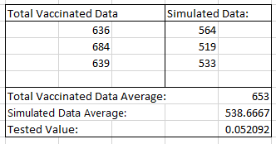The result is summed up in Table 1 which is shown below. This is based on the three days’ worth of data compared to the simulation results based on the replications. We then get the total average of the vaccinated person and the average for the simulated data.

Table 1. Comparison table for the total vaccinated data versus the simulated data

1. **Validation Report**

The data in Table 1 shows that the number of patients produced in the total vaccinated person based on the 3 days’ worth of data gathered at the actual site is bigger than the number produced in the simulation. The average of the total vaccinated data is also quite high compared to the average data in the simulation.

This validation only means that the objective of this project has not been met and it produced less efficiency than the existing system. It fails to produce a simulation that may help in optimizing the queueing system and reducing the amount of waiting time spent by the patients.

References:

Asgary, A., Najafabadi, M. M., Wendel, S. K., Resnick-Ault, D., Zane, R. D., & Wu, J. (2021). Optimizing planning and design of COVID-19 drive-through mass vaccination clinics by simulation. *Health and Technology*, *11*(6). https://doi.org/10.1007/s12553-021-00594-y